

Architectural and engineering specifications

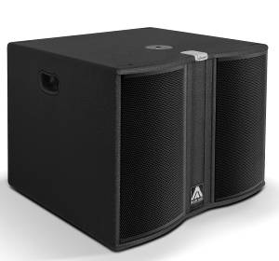
JK15W

• The subwoofer loudspeaker system shall have one ferrite magnet 15-inch low frequency transducer loaded in a band-pass tuned enclosure. It shall be rated at a nominal impedance of 8 ohms.

• The usable bandwidth shall be 38Hz to 200Hz (-10dB).

• SPL, measured at 1W and 1m under free field conditions shall be 98dB.

• Maximum continuous musical program shall be 800W.

• Enclosure shall be band-pass type with some lateral rectangular ducts.

• Enclosure cabinet construction shall consist of birch plywood with a black textured finish. Dimensions shall be 630 mm (24,8 inch) wide, 475 mm (18,7 inch) high, 630 mm (24,8 inch) deep. Enclosure weight shall be 35,5 Kg.

• The front enclosure shall be protected by two steel grilles with acoustically transparent foam. The grilles shall be secured via screws to keep it in place when facing the cabinet downwards.

• The cabinet shall feature a round socket with M20 thread located on the top panel to allow full-range enclosure coupling.

• Electrical connections shall be made via one of the two 4-pole NL4MPR Speakon connectors with the following configuration: +1/-1 signal input, +2/-2 disconnected.

• The loudspeaker system shall be the Master Audio® Joker JK15W.

